[×](javascript:void(0)) Home About gallery testimonial Contact

Login





**Sports  
Cycle**

It is a long established fact that a reader will be distracted by the readable content of a page when looking at its layout. The point of using Lorem Ipsum is that it has a more-or-less normal distribution of letters, as opposed to using 'Content here, content

**About Us**

It is a long established fact that a reader will be distracted by the readable content of a page when looking at its layout. The point of using Lorem Ipsum is that it has a more-or-less normal distribution of letters, as opposed to using 'Content here, content here', making it It is a long established fact that a reader will be distracted by the readable content of a page when looking at its layout. The point of using Lorem Ipsum is that it has a more-or-less normal distribution of letters, as opposed to using 'Content here, content here', making it

**Our Cycles**

t is a long established fact that a reader will be distracted by the readable content of a page when looking at its layout. The point of using Lorem Ipsum

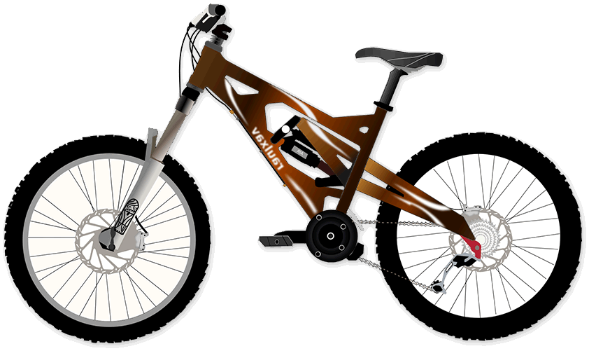

Previous Next

**Contact Us**

Top of Form









Bottom of Form

**Testimonial**

consectetur adipiscing elit, sed do eiusmod tempor incididunt ut labore et dolore magna

**Rooty**

(lcc)



consectetur adipiscing elit, sed do eiusmod tempor incididunt ut labore et dolore magna aliqua. Ut enim ad minim veniam, quis nostrud exercitation consectetur adipiscing elit, sed do eiusmod tempor incididunt ut labore et dolore , quis nostrud exercitation



**Important Link**

* Home
* About Us
* Our Latest Event
* Our Latest Article
* Join With Us

**Social Link**

* Facebook
* Linkedin
* Twitter
* Youtube
* Pinterest

**Subscribe With Us**

Lorem ipsum dolor sit amet, consectetur adipisicing elit. Fuga



Subscribe